**Integration Testing Results [FF]**

**Introduction**

This section presents an overview of the results from testing SMIRK in ESI Pro-SiVIC. As specified in the System Test Specification, we measure seven metrics for each test case execution, i.e., MinDist, TimeTrig, DistTrig, TimeBrake, DistBrake, Coll, and CollSpeed.

**Results**

Table 1 presents the results from executing the test cases representing operational scenarios with pedestrians, i.e., TC-OS-[1–25]. From the left, the columns show 1) test case ID, 2) the minimum distance between ego car and the pedestrian during the scenario, 3) the difference between TimeTrig and TimeBrake, 4) the difference between DistTrig and DistBrake, 5) whether there was a collision, 6) the speed of ego car at the collision, and 7) the initial speed of ego car. We note that 2) and 3) are 0 for all 25 test cases, showing that the pedestrian is always detected at the first possible frame when TTC ≤ 4s, which means that SMIRK commenced emergency braking in all cases. Moreover, we see that SMIRK successfully avoids collisions in all but two test cases. In TC-OS-5, the pedestrian starts 20 m from ego car and runs towards it while it drives at 16 m/s – SMIRK brakes but barely reduces the speed. In TC-OS-9, the pedestrian starts only 15 m from ego car but SMIRK significantly reduces the speed by emergency braking.

Table 1: Test results of metrics collected during execution of TC-OS-[1-25].

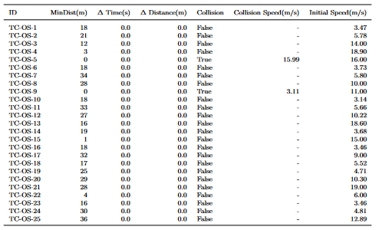

The remaining system test cases corresponding to non-pedestrian operational scenarios (TC-OS-[26–38]) and all test cases with jitter (TC-RAND-[1–38]) were also executed with successful test verdicts. All scenarios with basic shapes on collision course were rejected by the safety cage architecture, i.e., SMIRK did never commence any ghost braking. In a virtual conclusion of test meeting, the first three authors concluded that TC-RBT-1 and TC-RBT-2 had passed successfully. Finally, Figure 1 shows the distribution of inference speeds during the system testing. The median inference time is 22.0 ms and the longest inference time observed is 51.6 ms. Based on these results we conclude that TC-RBT-3 passed successfully and thus provide evidence that SYS-PER-REQ6 is satisfied.

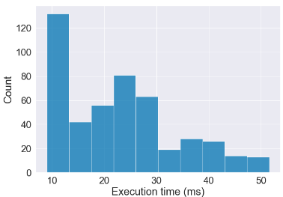

Figure 1: Distribution of inference speeds during system testing.